**MINNAL**

**Software Design Document**

**(SDD)**

**Use Case Diagram**

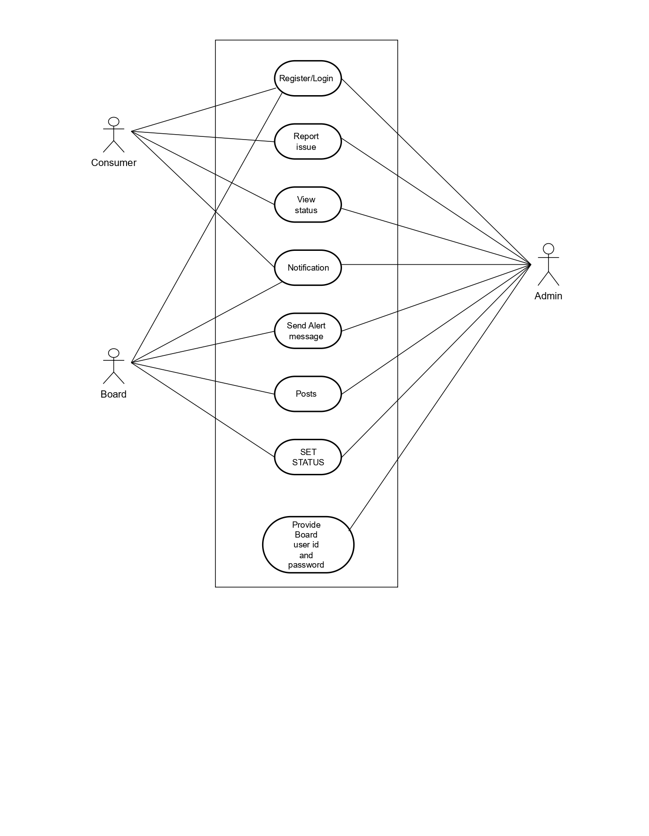

**Activity Diagram: Consumer**

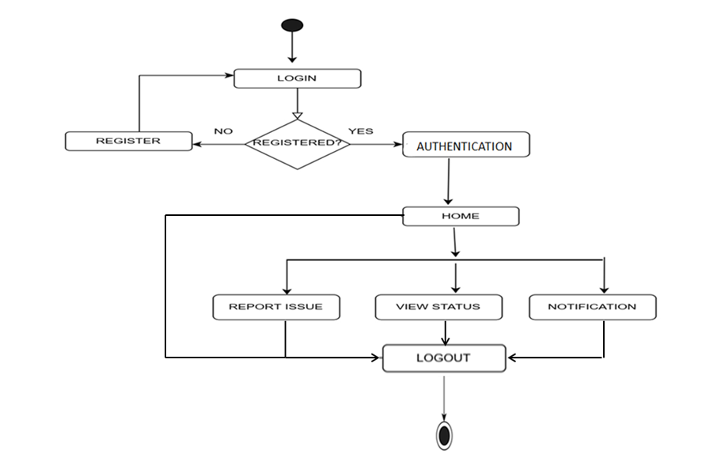

**Activity Diagram: Board**

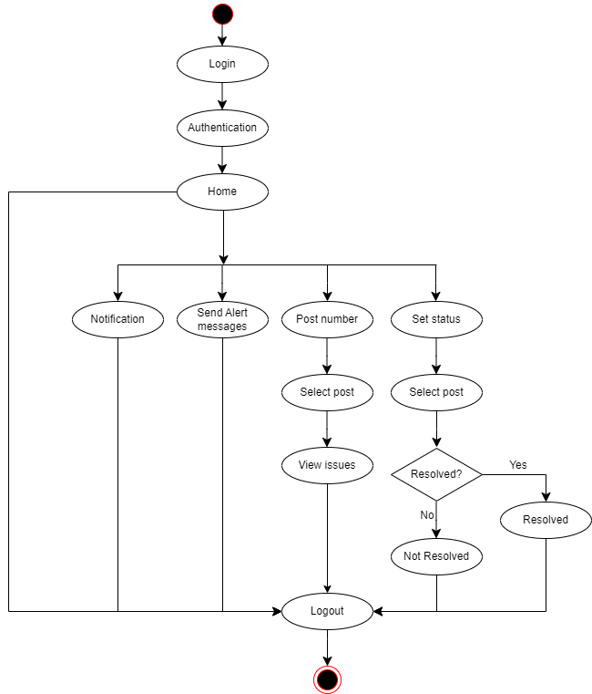

**ER Diagram**

